## [Mystery Surrounding Denver International Airport](http://xenophilius.wordpress.com/2009/02/17/mystery-surrounding-denver-international-airport/)

Posted by [Xeno](http://www.xenophilia.com) on February 17, 2009

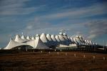

Denver International Airport (DIA) has been the subject of numerous conspiracy theories since it’s opening in 1995.

Many investigators have directly questioned airport officials in an attempt to dispel the myriad of rumours - officials however have been reported to be evasive and secretive which has fuelled the conspiratorial fires.

In this article, a number of the DIA’s “oddities” along with conspiracy theories surrounding them have been outlined. …

Five large buildings were fully constructed and subsequently deemed to have been positioned incorrectly - unusually, they were buried and the current airport constructed on top of the “incorrect” structures.

The cost of the project over-ran significantly, from $1.5 billion to $5.3 billion.

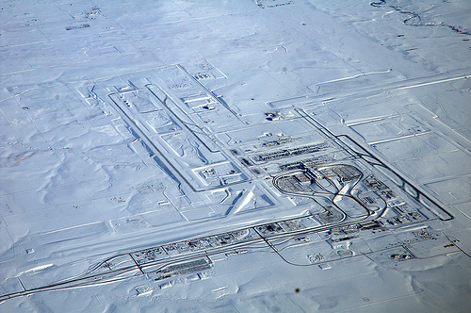

The layout of the airport from an aerial view, appears to have been designed in a shape resembling a swastika - synonymous with the Nazi party - it should be noted however that the swastika symbol may not necessarily be sinister, the symbol is over three thousand years old and has been used by many cultures to represent life, the sun, power, strength and good luck.

The swastika shape may have also been a fluke, based upon an optimum airport / runway design. …

### Underground base

Phil Schneider was an ex-governmental geologist who turned whistleblower on many covert operations. During a series of high profile lectures, he revealed that in the last year of DIA construction, the underground levels of the airport were connected to a vast eight level deep underground base.

Phil Schneider also made comment in regard to an unusual and high level of electro-magnetic energy which he personally experienced within the underground tunnels.

These revelations led to much speculation about the usage of the underground facility - I have come across a number of speculations, including, the base will be an “ark” - used in the event of a cataclysmic planetary event, others believe that it is a secret military base, a test ground for secret experimental technology or weaponry. There is even speculation that the base could be used as a concentration camp. …